Chi-square probability distribution function

The continuous random variable x has a chi-square probability distribution, with ν degrees of freedom, if its mathematical function is given by



where ν > 0.

Mean and variance of a random variable with this distribution:

E(x) = μ = ν and Var(x) = σ2 = 2ν

Notes:

* ν is a parameter. Different shapes of the probability distribution result from different values of ν.
* The name “chi-square” could equivalently be expressed as χ2.

Example: Chi-square probability distribution plot

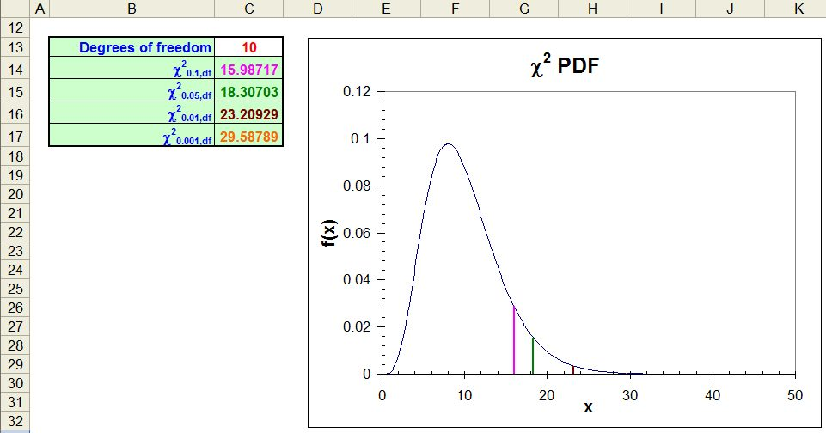

Example: Finding probabilities and quantiles from a chi-square distribution

To find P(x < 3.84) with ν = 1, we could use integration:



Instead, we can use the *pchisq()* function:

> pchisq(q = 3.84, df = 1)

[1] 0.94996

To find the 1 – α/2 quantile from a chi-square distribution, we could use integration:



where we would solve for c in the above equation. Instead, we will use the *qchisq()* function:

> alpha<-0.1

> qchisq(p = 1 - alpha/2, df = 1)

[1] 3.8415

The *dchisq()* function allows us to evaluate f(x) so that we can plot the distribution:

> curve(expr = dchisq(x = x, df = 1), from = 0, to = 5, col

= "red", lwd = 2, main = "Chi-square distribution with

1 DF", ylab = "f(x)", xlab = "x", n = 1000)

> abline(h = 0)



Obviously, the distribution is quite skewed for ν = 1 degree of freedom. Below is another plot of the distribution, but with ν = 10 degrees of freedom:

